**STEPS TO DOWNLOAD CRAN (R CONSOLE):**

**Step 1:**

Open the URL <https://cran.r-project.org/> from which you need to download the console. This will open a new window:

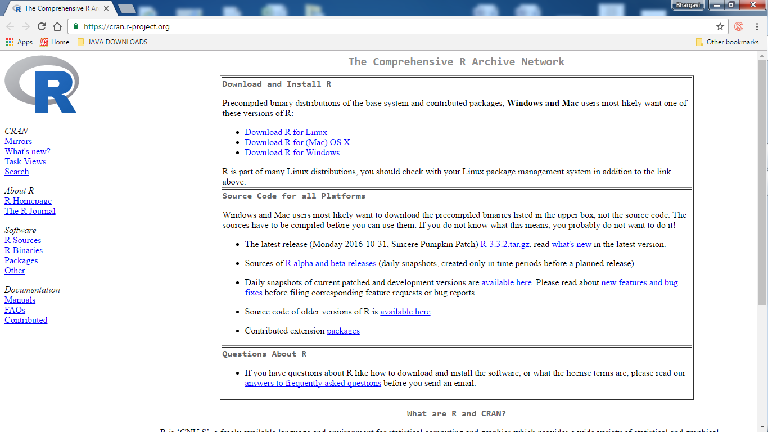

The redirected window will have the downloading process and some basics of R and CRAN (Comprehensive R Archive Network)

**Step 2:**

Now click on the download link as per your operating system.

For now let us consider the downloading process of “Windows” .This click will lead to:

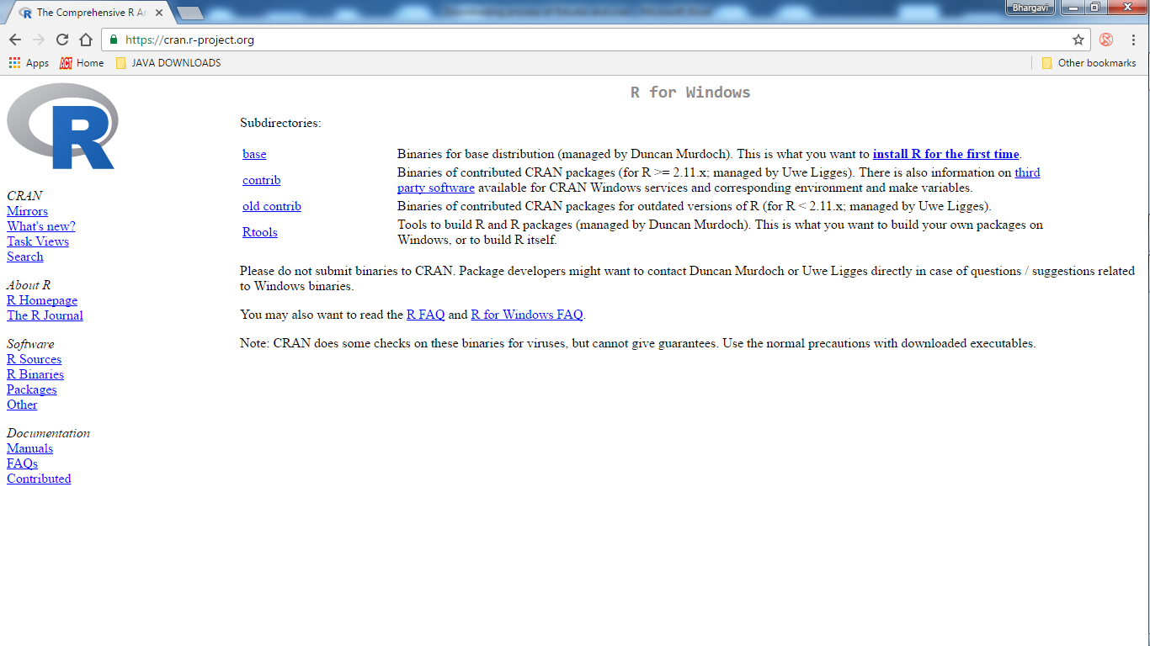**Step 3:**

Click on “Install R for the first time” then you will be shown the downloading link for the latest version of R (for now the latest is R – 3.3.2)

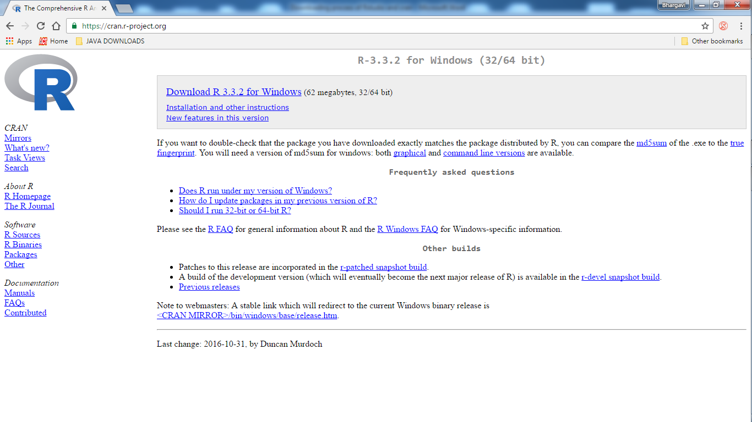

**Step 4:**

Click on the “download” click to start the downloading process. Once the downloading process is done an .exe file is seen which on open will show:

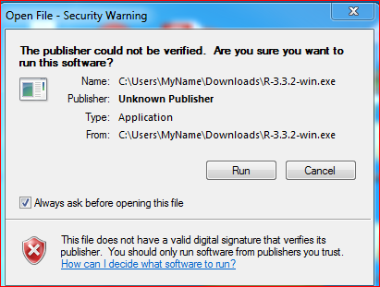

**Step 5:**

Click on run then it shows a window to setup a language, select your understandable language which gives you flexibility to install faster:

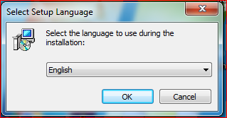

For now we are processing with “English”.

**Step 6:**

Now starts the initialization process and follow the below steps:

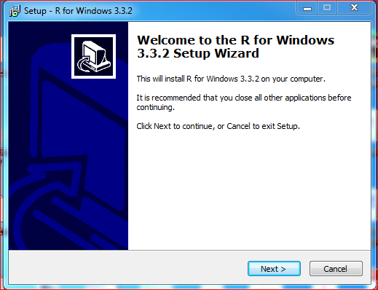

**Step 7:**

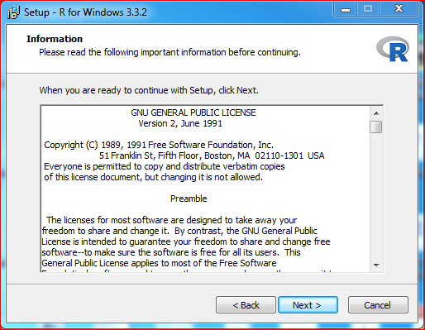

**Step 8:**

Browse the folder in which you want to save and install R

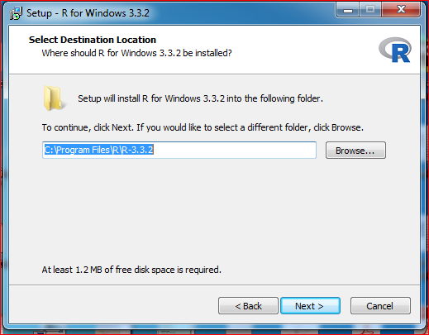

**Step 9:**

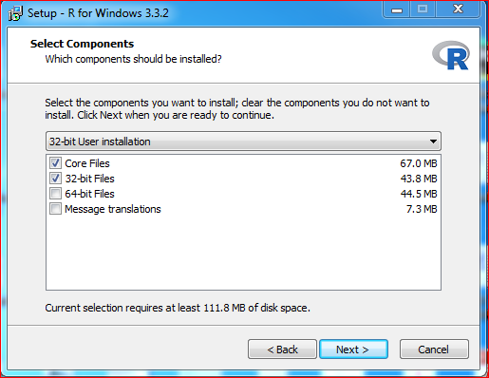

**Step 10:**

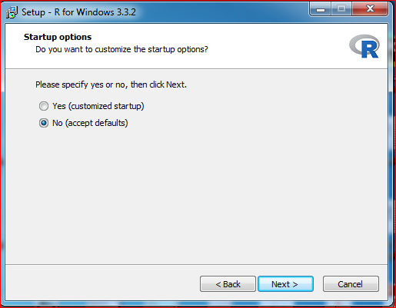

**Step 11:**

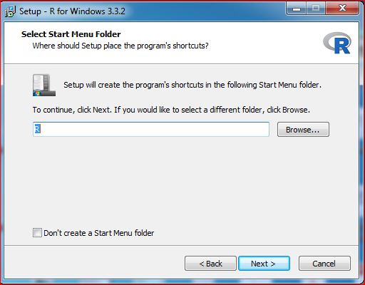

**Step 12:**

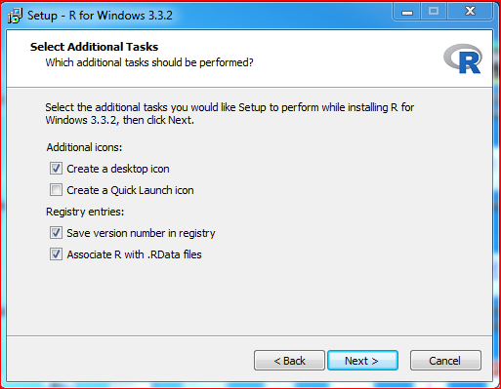

**Step 13:**

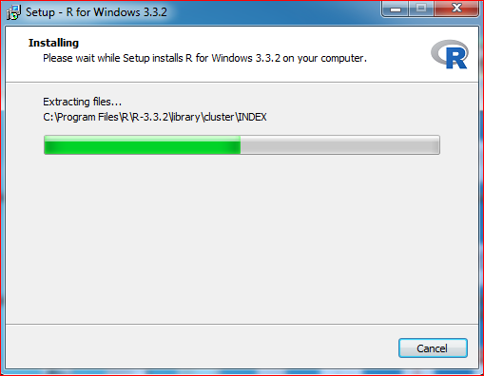

**Step 14:**

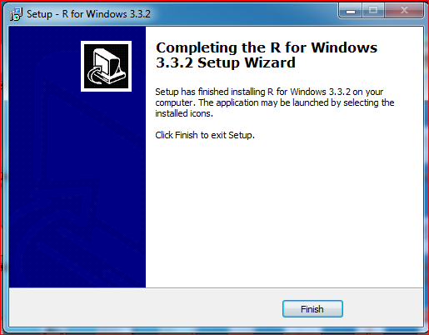

**Step 15:**

On Click on “finish”, an icon is created  (3.3.2 version) .Double click on it to start with R programming!!..

**STEPS TO DOWNLOAD R Studio (R-IDE):**

**Step 1:**

Open the URL <https://www.rstudio.com/> which gives you:

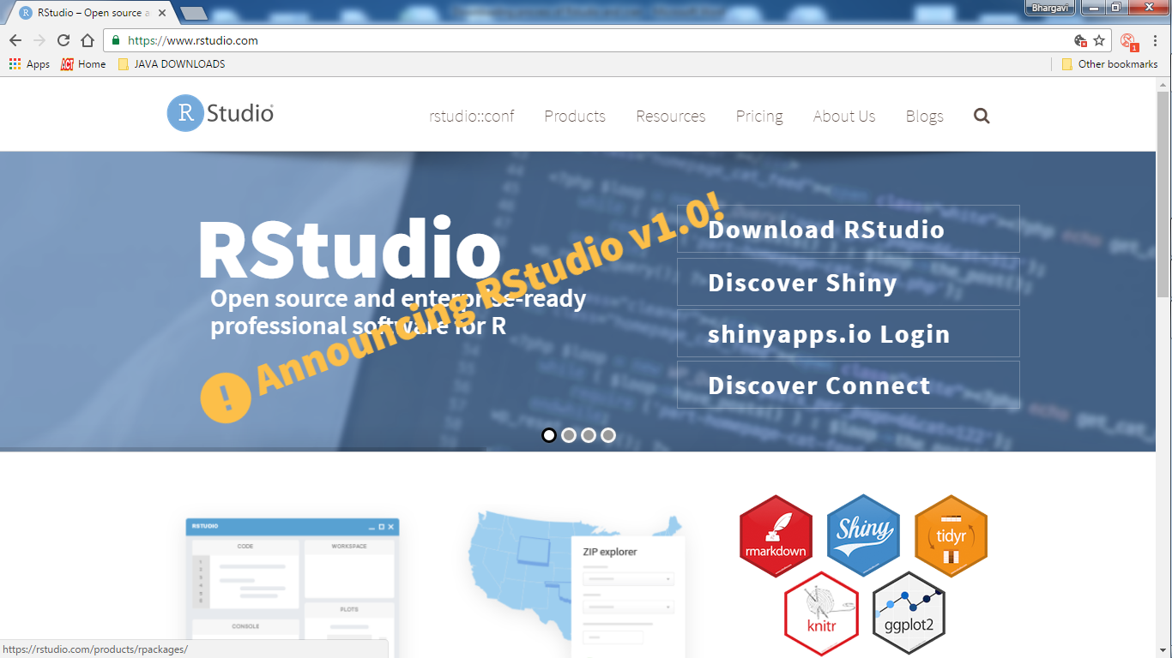

**Step 2:**

Click on “Products” tab and select “RStudio” then shows as below:

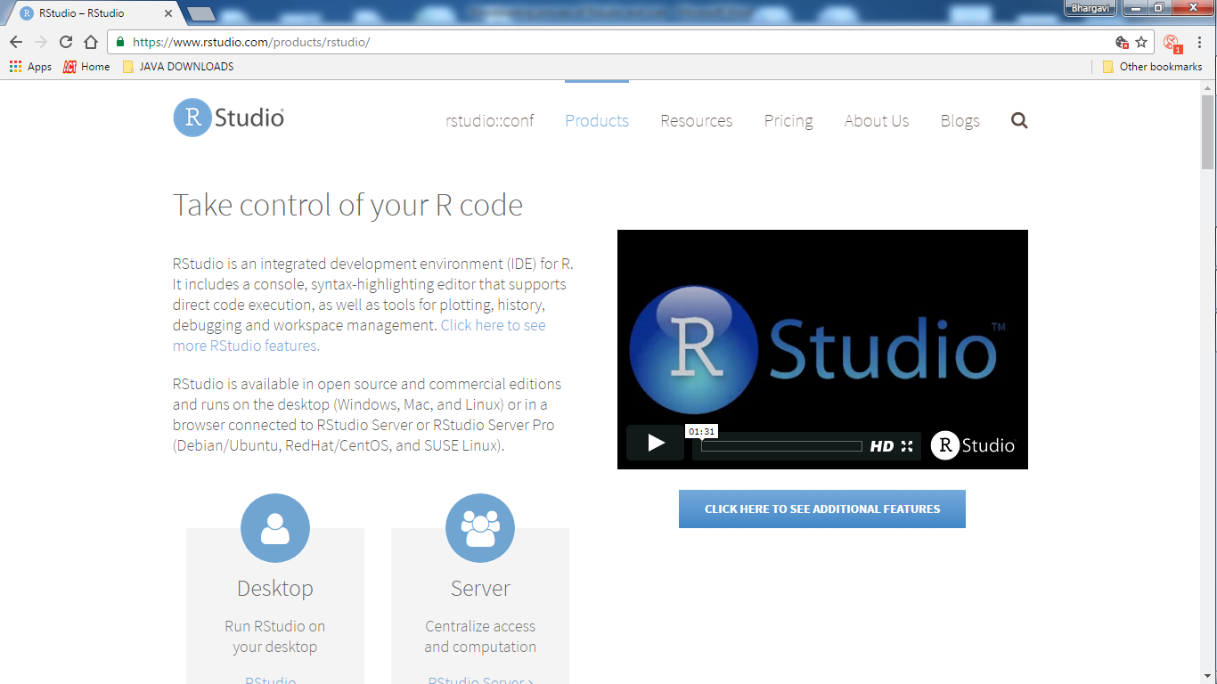

**Step 3:**

Click on “Desktop (Rstudio on desktop)” then we get:

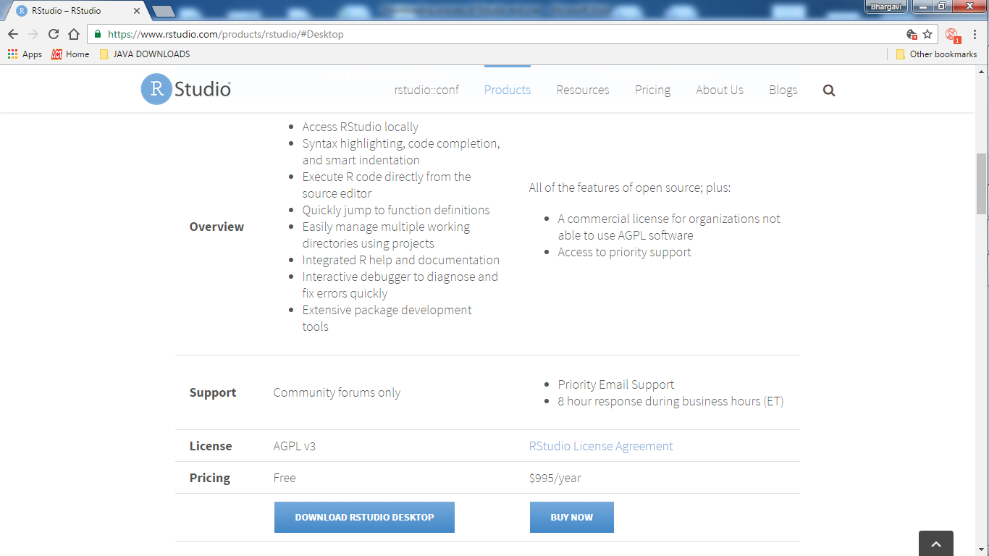

**Step 4:**

Click on “DOWNLOAD RSTUDIO DESKTOP” then:

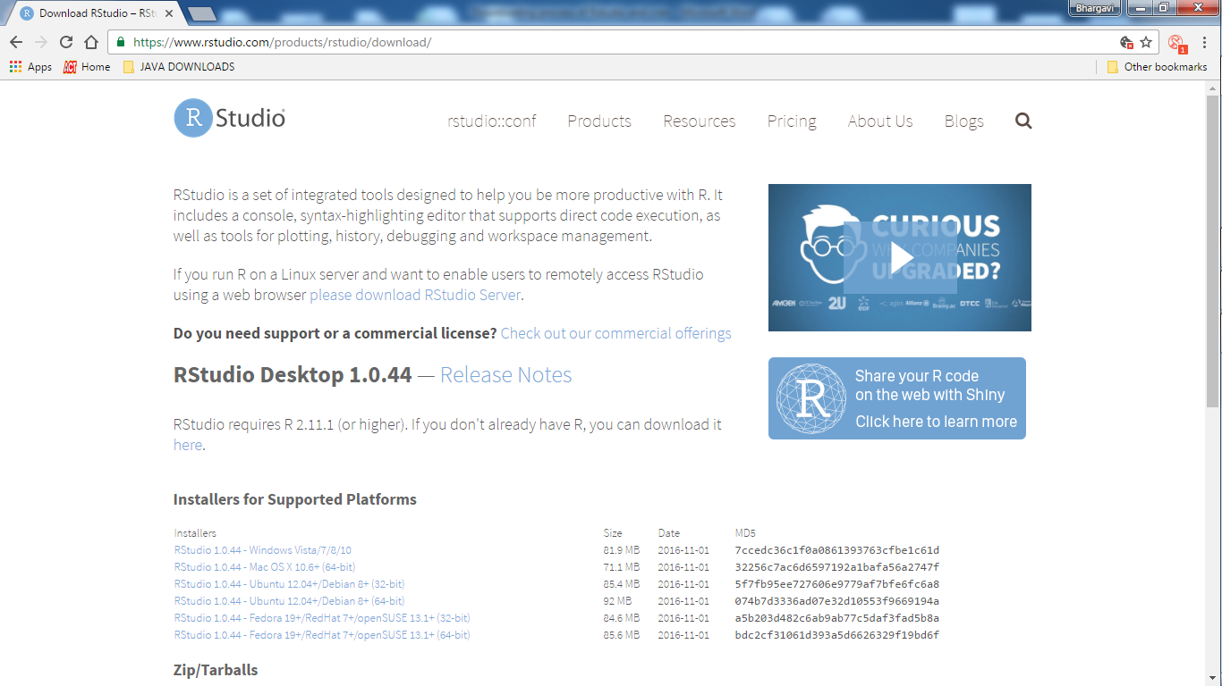

**Step 5:**

Install Rstudio as per your PC’s platform. Upon installation an .exe file is downloaded. Open the exe file and setup Rstudio: (by following below steps)

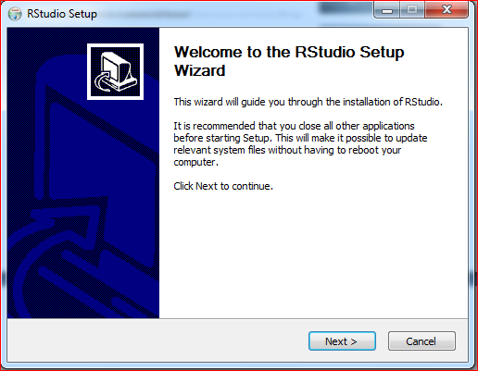

**Step 6:**

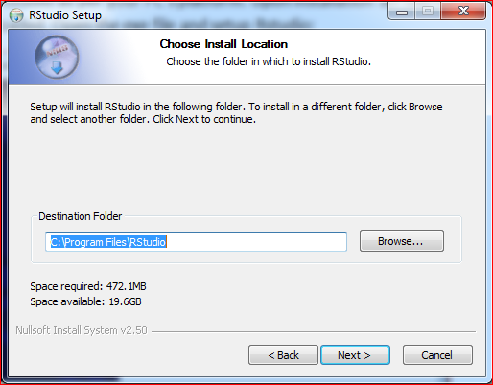

**Step 7:**

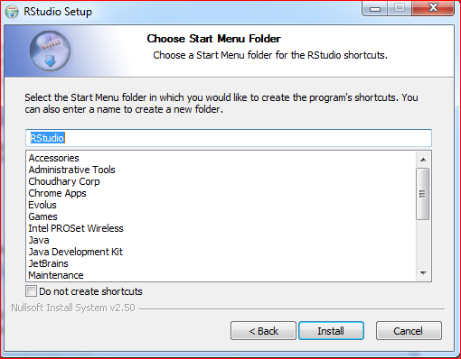

**Step 8:**

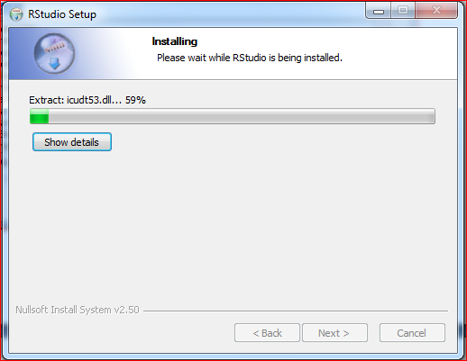

**Step 9:**

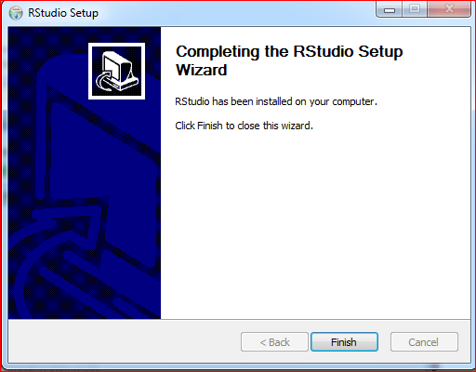

**Step 10:**

Once clicked on finish, you will find the Rstudio icon in “All Programs” .Click on it and start with “R”..